PyraPOD Global Inc
A1.5PC4G17F
2199-3151 Lakeshore Rd
Kelowna, BC V1W 3S9
Phone: 1-250-412-4918

To Pioneers Who Have Deep Insight

July 15, 2021

Rough Order of Magnitude (ROM) Supply Offer for PyraPOD Products

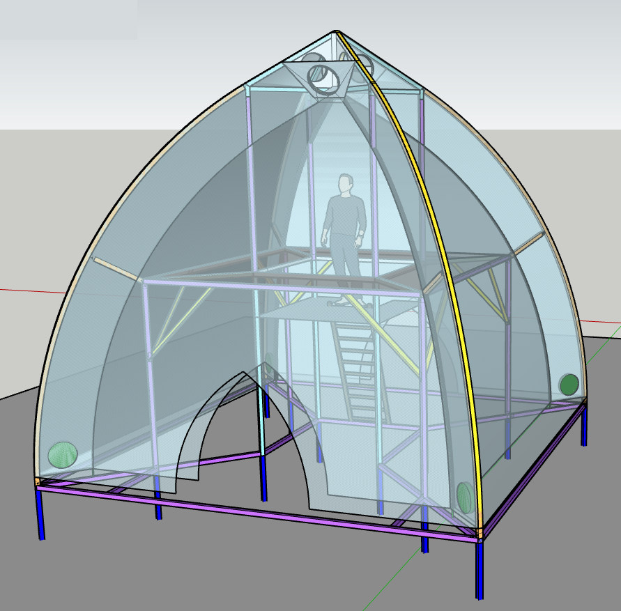
PyraPOD Global Inc (PGI) will design, engineer, fabricate, supply and supervise the installation of a fabric structure enclosure as described and specified in construction drawings and installation brief for the Aquaponics 1 and half floor PyraPOD4 Column-supported Grande-17 (A1.5PC4G17F), based on a modular PyraPOD4 structure with SolaRoof CCEE technology (B1.5PC4G17F), erected with our supervision with minimum pier footings supplied by the customer to PGI specifications. This product will be delivered with integral SolaRoof Technology CCEE Equipment, which is included in the supply price. The below price is valid for supply of a standard PyraPOD Product until such time as PGI may provide you a revision of this offer, when a final Purchase Order is obtained. Our price proposal contained herein is offered in respect to any contract/purchase order to be issued for Proof of Concept (POC) projects now under development.

PRICE PROPOSAL:

Aquaponics PyraPOD4 Grande-17: $12,000 US

Product sectional breakdown:
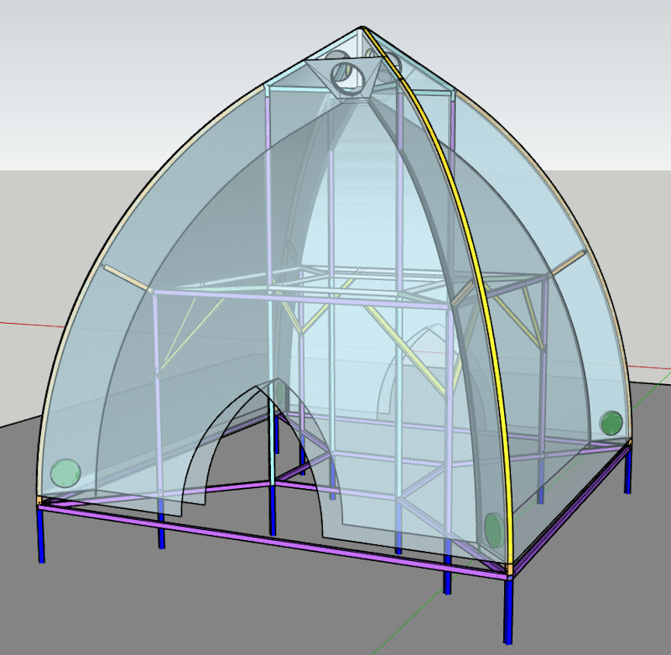
  - B1.5PC4G17F structures to be made with 50x50x3mm aluminum square tube columns and beams with connector hubs to form the backbone with PyraPOD building envelop (roof and walls made of fiber glass with silicone coatings) and needed elements such as bubble generators, soap reservoirs, plumbings, etc. with Dynamic Liquid Bubble Insulation and Shading and Liquid Film Climate Control to create a winter warm and summer cool environment ($10,000)
  - A central platform, a ladder, and metal wire mesh shelves with supporting frames to be used for aquaponics gardening or other type of growing systems ($2,000).

Scope of Work

Design/Engineering/Manufacturing
DGI includes the following:
- One (1) design concept refinement.
- Architectural/engineering and shop drawings by PGI suppliers for the prefabrication of all parts and components of the PyraPOD structure.
- Manufacture and supply of the prefabricated structure to approved production drawings, with supervision of the assembly and construction of the PyraPOD product included.
- Design and engineering of all associated hardware directly connected to fabric envelope and the interior film liner, forming the bubble cavity in between with a space of 2 feet.
- Design and patterning for the prefabrication of the PyraPOD membrane for all roof and wall areas as required.
- Manufacture and supply fabric cover and liner materials
- Prefabricated exterior covering with engineered fabric that is fireproof, durable and UV protection.
- Zipper fit interior liner with high light transmittance for easy upgrade and maintenance
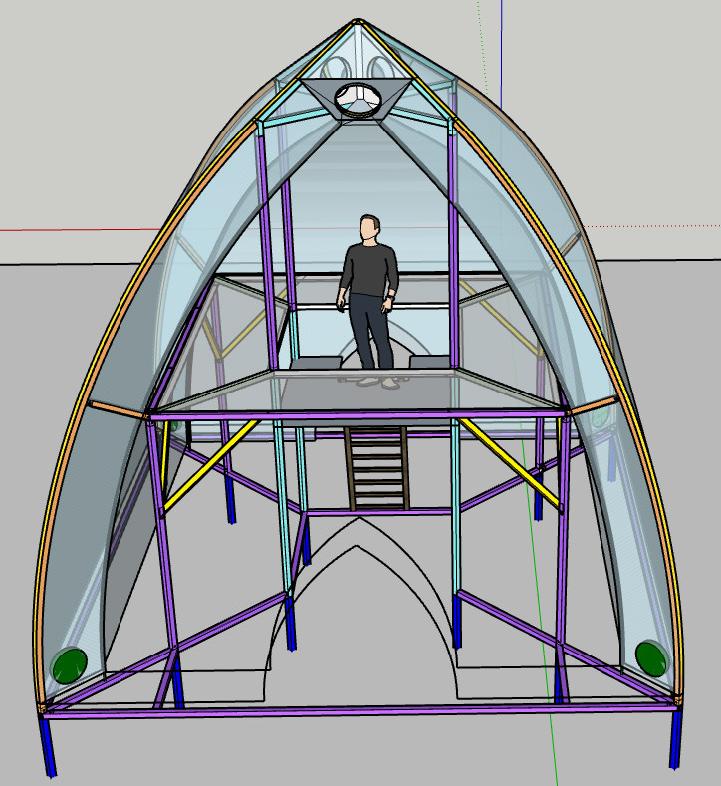
- Seasonal zip-in double-layer doors to provide ventilation and bubble insulation when needed.
- Modular aluminum structure with natural corrosion protection.
- A central platform 5’x5’ with a ladder for easy access to the top level.
- A set of four 8’x3’ metal wire mesh with support frames to form a four-side-surrounding shelving for gardening.
- Engineering plastics and/or aluminum clamping plates as required.
- Hardware such as nuts, bolts, turnbuckles, shackles, membrane plates, etc.
- One year product warranty and manufacturers prorated warranty (Typically 5 years).
- SolaRoof Technology equipment as specified for the standard Product.

Excluded from our contract is the following:
- Performance Bonds, insurance and payment of freight.
- Design or Engineering of general mechanical, electrical, lighting and lightning protection systems attached to tension fabric structure.
- Design or Engineering of interior finishes and fittings related to the culture the food crops, waste management systems and electrical and water regenerative systems. However, PGI intends to cooperate with suppliers for an optimum integration of such technology and control systems with the PyraPOD.
- Site survey and site planning.
- Any general foundation and site work, or landscaping.
- Design or Engineering of non standard concrete footings, piers, foundations or ground anchors. Design or Engineering of other site work or performance of General Contractors work.
- Special architectural variances from the standard products package, which shall be quoted as an extra work after consultation with the Project Architect.

Delivery of product
Furnished Materials - delivery to site approximately 2 months from receipt of Down Payment, depending on best effort on shipping time and costs.

Installation
PGI will not install but will provide remote supervision during the site assembly of the said product. PGI assumes the client will supply the following if there is a need for on-site supervision or even full installation:

1. Reasonable compensation for the work to be assisted on site.
2. Accommodation and air fare for PGI personnel for duration of onsite work.
3. PGI shall be reimbursed for work stoppage or delays caused by other parties.

Project Schedule
Note: No work or schedule will begin until PGI receives a fully executed contract or purchase order.

Payment Terms (due upon receipt)
A $7,000 deposit is required in order to proceed. A second invoice will be billed upon completion of of manufacturing, which is due upon date of shipment of the manufactured product.

Additional Comments:
This is a one-time introductory special offer that will not be given in the future. It is intended for pioneers who recognize the tremendous potentials and market for such a product, including a series of products that spin off from this, such as AquaPOD premium, SwimPOD, SpaPOD, CityPOD, etc.

Any changes or services outside this agreement and any deviations from the drawings or specifications without the consent agreement by both PGI and the owner/contractor will be subject to a Change Request/Change Order. Additional funds will be invoiced as required.

Regards,

Jun (Aubrey) Zhang, CEO of PGI
Richard Nelson, CTO of PGI

ACCEPTED BY THE BUYER,

_________________________________
Authorized Signature

Notice to proceed Date ______________

